AGENDA

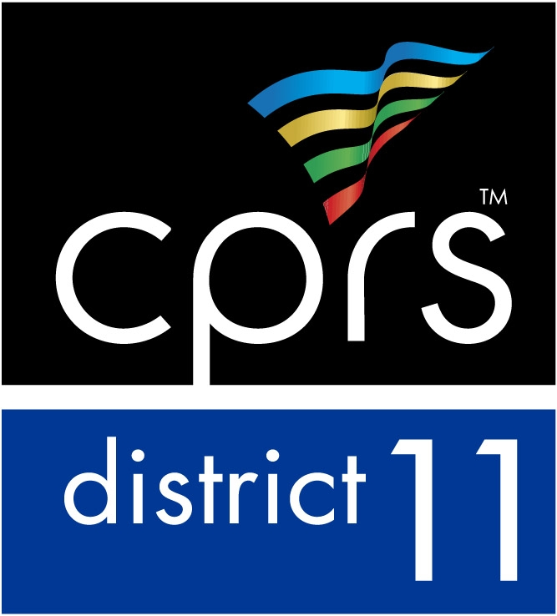
District 11, California Park and Recreation Society

Board Meeting

May 20, 2020

Location: ZOOM

Conference: 669-900-6833 Meeting ID:

Attendees: Ryan Morais, President City of Chino
Don Craw, President- Elect RivCo Parks
Jessica Ochoa, Vice President City of Riverside
RJ Saldana, Treasurer City of Chino
Socorro G. Huerta, Secretary City of Murrieta
Mike Adams, Director of Communications City of Chino Hills
Candice Smith, Director of Board Relations City of Ontario
Barb Adair, Legislative Section Desert Recreation District
Jarvis Crawford, Recreation Section City of Palm Springs
Kristin Moorman, Aquatics Section City of Riverside
D&O Section Robertson Recreation Surfaces
Doug Grove, Administrators Section RHA Landscape Architects
Therapeutic Section OPEN
Education Section OPEN
Aging Section OPEN

Helen Hernandez, Region 4 Representative City of Baldwin Park
Silvia Avalos, Region 4 Admin Section Rep City of Chino
Krystal Smith, Region 4 Recreation Section Rep City of Covina
Region 4 D&O Section Rep Open

1. | Call to Order: Ryan Morais, President
2. | Roll Call: Socorro Huerta, Secretary
3. | Approval of the Minutes  - April 2, 2020 Meeting/Installation
4. | Approval of the Agenda
5. | Presentations None
6. | Treasurer’s Report: RJ Saldana
7. | Event Reports  - Taco About It Tuesday
8. | New Business  - Canva  - Calendar
9. | Continued Business  A&I  - Social Media  - Virtual Educational component  - Fall/Winter  - Susan Barton  - Elections  - Taco About It Tuesday
10. | Announcements / Section Reports
11. | Next Meeting  - Third Wednesday of the month @ 1:00 p.m./June 17 via Zoom
12. | Adjournment

Additional Instructions:

